Sql task

https://gist.github.com/rvsp/51ac78f183db0cebde984fd45b90b2a8

1)Creating tables in the database

1)CREATE TABLE users (student_name varchar(45), student_email varchar(40),id PRIMARY KEY);

2)CREATE TABLE codekata (

problem varchar(45), solved boolean,

PersonID int,

FOREIGN KEY (PersonID) REFERENCES Persons(PersonID)

);

3)CREATE TABLE attendance (

day varchar(45), attendance boolean,

attendanceid int,

FOREIGN KEY (attendanceid) REFERENCES Persons(attendanceid)

);

4)create TABLE tasks (

Task varchar(45), dateofsubmission varchar(45) ,

taskid int NOT NULL,

PRIMARY KEY (taskid)

);

5)CREATE TABLE topics (

Topic varchar(45), STD int,

topicsid int NOT NULL,

PRIMARY KEY (topicsid)

);

6)CREATE TABLE company_drives (

companyname varchar(45), position varchar(45),

comapnyid int,

FOREIGN KEY (comapnyid) REFERENCES Persons(comapnyid)

);

7) CREATE TABLE mentors (

mentorname varchar(45), mentorsubject varchar(45),

mentorid int,

FOREIGN KEY (mentorid) REFERENCES Persons(mentorid)

);

8) CREATE TABLE students_activated_courses (

course_date varchar(45), activecourse_name varchar(45),

courseid int,

FOREIGN KEY (courseid) REFERENCES Persons(courseid)

);

9) CREATE TABLE courses(

coursename varchar(45), course_duration_min Int,

courseid int,

FOREIGN KEY (courseid) REFERENCES Persons(courseid)

);

2)Inserting data in the tables

1)

INSERT INTO users

VALUES ('yusf', 'yusf@mail.com'),

('naveen', 'naveen@mail.com'),

('shibin', 'shibin@mail.com'),

('judes', 'judes@mail.com'),

('sneha', 'sneha@mail.com');

SELECT * FROM users;

2)

INSERT INTO codekata

VALUES ('string', 1,2),

('array', 0,5),

('loops', 1,4),

('function', 1,3),

('data structures', 0,2),

('string', 1,1),

('array', 0,1),

('loops', 0,2),

('function', 1,3),

('data structures', 0,4),

('array', 0,5),

('loops', 1,3),

('function', 1,2),

('data structures', 0,1);

SELECT * FROM codekata;

3)

INSERT INTO attendance

VALUES ('modany', 1,2),

('Tuesday', 0,5),

('Wednesday', 1,4),

('Friday', 1,3),

('tuesday', 0,2),

('Wednesday', 1,1),

('Friday', 0,1),

('Monday', 0,2),

('Thusday', 1,3),

(' wednesday', 0,4),

('tuesday', 0,5),

('saturday', 1,3),

('monday', 1,2);

SELECT * FROM attendance;

4)

INSERT INTO topics

VALUES ('MAths', 2,1),

('Web dev', 8,2),

('Social', 5,3),

('DBMS', 10,4),

('OS', 11,5);

SELECT * FROM topics ;

5)

INSERT INTO tasks

VALUES ('MAths', "moday",1),

('Web dev', "tuesday",2),

('Social', "wednesday",3),

('DBMS', "thursday",4),

('OS', "friday",5);

SELECT * FROM tasks ;

6)

INSERT INTO company_drives

VALUES ('freshworks', "developer",1),

('deshaw', "marketing",2),

('TCS', "sales",3),

('Infosys', "BA",4),

('dynamic', "financial anlyst",5),

("dreamers","HR",2),

('freshworks', "developer",3),

('deshaw', "marketing",1),

('TCS', "sales",5),

('Infosys', "BA",2),

('dynamic', "financial anlyst",1),

("dreamers","HR",4);

7)

INSERT INTO mentors

VALUES ('ram', "developer",1),

('sai', "CSE",2),

('chirag', "ECE",3),

('ravina', "BA",4),

('sagar', "financial anlyst",5),

('prena', "CSE",2),

('santhish', "ECE",3),

('jackie', "BA",4),

('ram', "developer",3),

('sai', "CSE",1),

('chirag', "ECE",4),

('ravina', "BA",5),

('sagar', "financial anlyst",2),

('prena', "CSE",3),

('santhish', "ECE",1),

('jackie', "BA",3),

('ram', "developer",2),

('sai', "CSE",1),

('chirag', "ECE",2),

('ravina', "BA",5),

('sagar', "financial anlyst",3),

('prena', "CSE",4),

('santhish', "ECE",2),

('jackie', "BA",1);

8)

INSERT INTO students_activated_courses

VALUES ('monday', "developer",1),

('friday', "CSE",2),

('teuesday', "ECE",3),

('wednesday', "BA",4),

('Friday', "financial anlyst",5),

('Thursday', "CSE",2),

('wednesday', "ECE",3),

('Tuesday', "BA",4),

('Wednesday', "developer",3),

('Friday', "CSE",1),

('Monday', "ECE",4),

('Thursday', "BA",5),

('Wednesday', "financial anlyst",2),

('Monday', "CSE",3),

('Saturday', "ECE",1);

select * from students_activated_courses

9)

VALUES ( "developer",45,1),

( "CSE",45,2),

( "ECE",45,3),

( "BA",45,4),

( "financial anlyst",45,5),

( "CSE",45,2),

( "ECE",45,3),

( "BA",45,4),

( "developer",45,3),

( "CSE",45,1),

( "ECE",45,4),

("BA",45,5),

( "financial anlyst",45,2),

( "CSE",45,3),

( "ECE",45,1),

( "BA",45,3),

( "developer",45,2),

( "CSE",45,1),

( "ECE",45,2),

( "BA",45,5),

( "financial anlyst",45,3),

("CSE",45,4),

( "ECE",45,2),

( "BA",45,1);

3) get number problems solved in codekata by combining the users

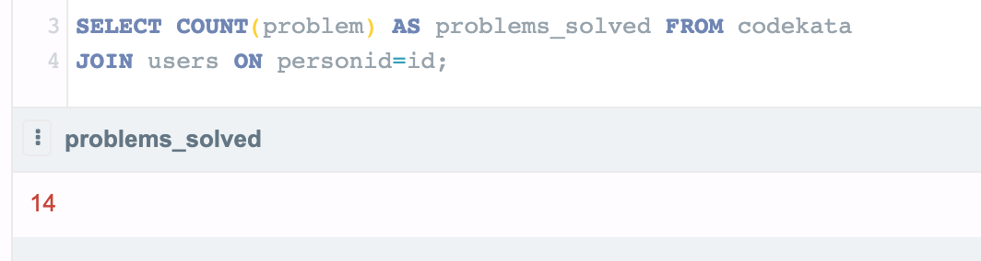

4) display the no of company drives attended by a user

5) combine and display students_activated_courses and courses for a specific user groping them based on the course.

6) list all the mentors

7) list the number of students that are assigned for a mentor

